Human Resources

Washburn University

263 Morgan Hall

1700 College

Topeka, KS 66621

To Whom It May Concern:

I am writing this letter of recommendation and support for Mr. Norm Mast as he applies for the Director of Information Systems and Services position at Washburn University. Norm has been a valued employee at Baker University for the past 5 years and brings experience from the business community and at the university level. He also has experience in management of the administrative system and as a faculty member. With his background, varied experiences, and outstanding leadership skills, I believe he is an ideal fit for your position.

Norm is an outstanding communicator. He can translate difficult technological terms into understandable language for end-users. From time to time, I interact with Norm on committees or in technology related meetings. I have been impressed with his ability to listen, to translate, and to bring a calm demeanor to challenging and sometimes contentious issues.

Norm is a hard worker and his Baker colleagues have consistently expressed how competent he is in the technological arena. He is a loyal and dedicated employee who will be missed at Baker University.

I hope you will consider his application seriously and if you have any questions, please feel free to contact me.

Sincerely,

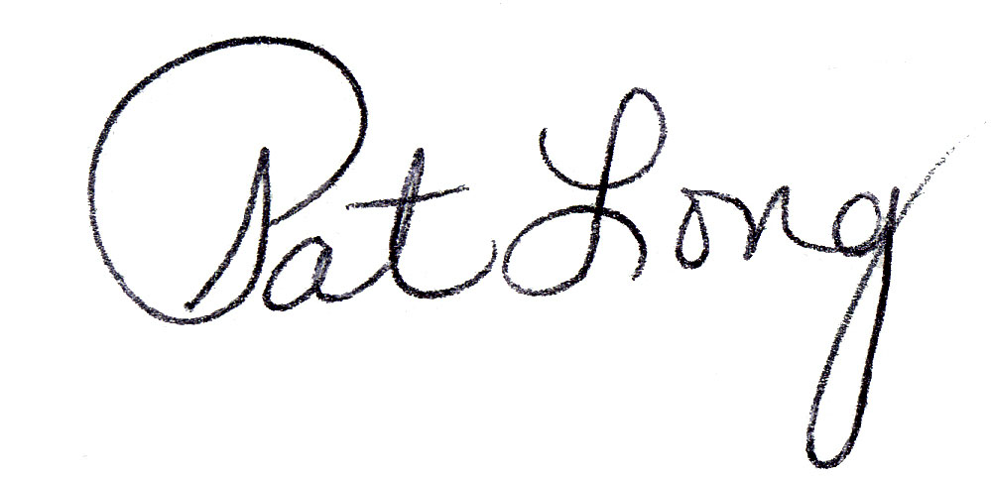

Patricia N. Long

